**East West University**

**LAB REPORT**

|  |  |
| --- | --- |
| **Course Code and Name:**  CSE 209 ; ELECTRICAL CIRCUIT | |
| **Experiment no: 04**  **Group no: Individual** | |
| **Experiment name:**  Bias Point Detail Analysis of DC Circuit With Independent Sources Using PSpice  Schematics | |
| **Name of student & Id:** | |
| B M Sharhia Alam | **ID:** 2021-3-60-016 |
| **Course Instructor information:**  M Saddam Hossain Khan(SHK)  Senior Lecturer  Department of Computer Science and Engineering  East West University | |
| **Date of Report Submitted:**  11 December ,2022 | |

**OBJECTIVE:**

1. To gain knowledge about fundamentals of PSpice.

2. To experiment Bias Point Detail of DC circuit using PSpice Schematics.

**THEORY AND EXPERIMENTAL METHODS:**

In PSpice the program is run in order to draw circuit schematics. The program will let us run simulations and see graphic results. In this method, the circuit is described by writing codes using the syntax of PSpice. The resulting file is called netlist. PSpice uses netlist as its input and simulates the circuit. In the other method, the circuit is drawn graphically using a software tool called Schematics. Then PSpice uses the Schematic circuit as its input and simulates it. In this experiment, we will learn to use the PSpice circuit simulation using Schematics. There are a lot of things can be done with PSpice such as design and draw circuits, simulate circuits, analyze simulation results.

**CIRCUIT DIAGRAM:**

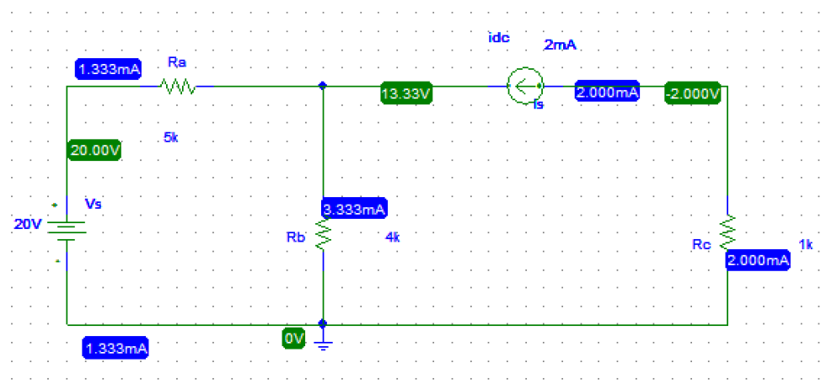

**Figure 01: Simple Simulated Circuit**

**\* Schematics Netlist \***

**R_Ra $N_0002 $N_0001 5k**

**R_Rb 0 $N_0001 4k**

**R_Rc 0 $N_0003 1k**

**V_Vs $N_0002 0 20V**

**I_Is $N_0003 $N_0001 DC 2mA**

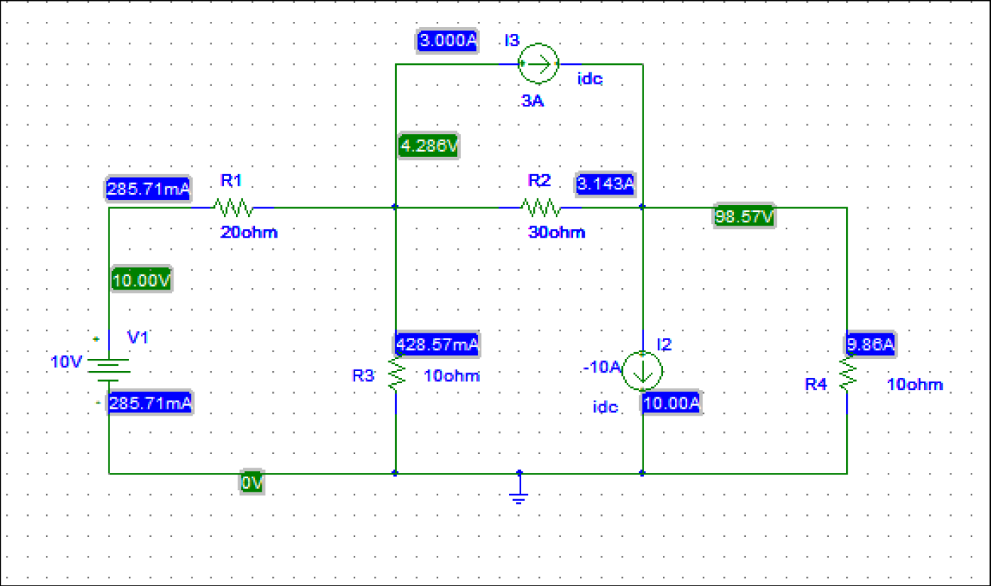

**Figure 02: Simulated Circuit for Lab Practice.**

**\* Schematics Netlist \***

**R_R4 0 $N_0001 10ohm**

**I_I2 $N_0001 0 DC -10A**

**R_R3 0 $N_0002 10ohm**

**V_V1 $N_0003 0 10V**

**I_I3 $N_0002 $N_0001 DC 3A**

**R_R2 $N_0002 $N_0001 30ohm**

**R_R1 $N_0003 $N_0002**

**Result and discussion**

By doing this experiment we have been able to simulate our circuits via PSpice and test the results. Previously we had tested our circuits practically, but this is more efficient.

**Post-Lab Report Answers:**

**Answers to the questions no: 01**

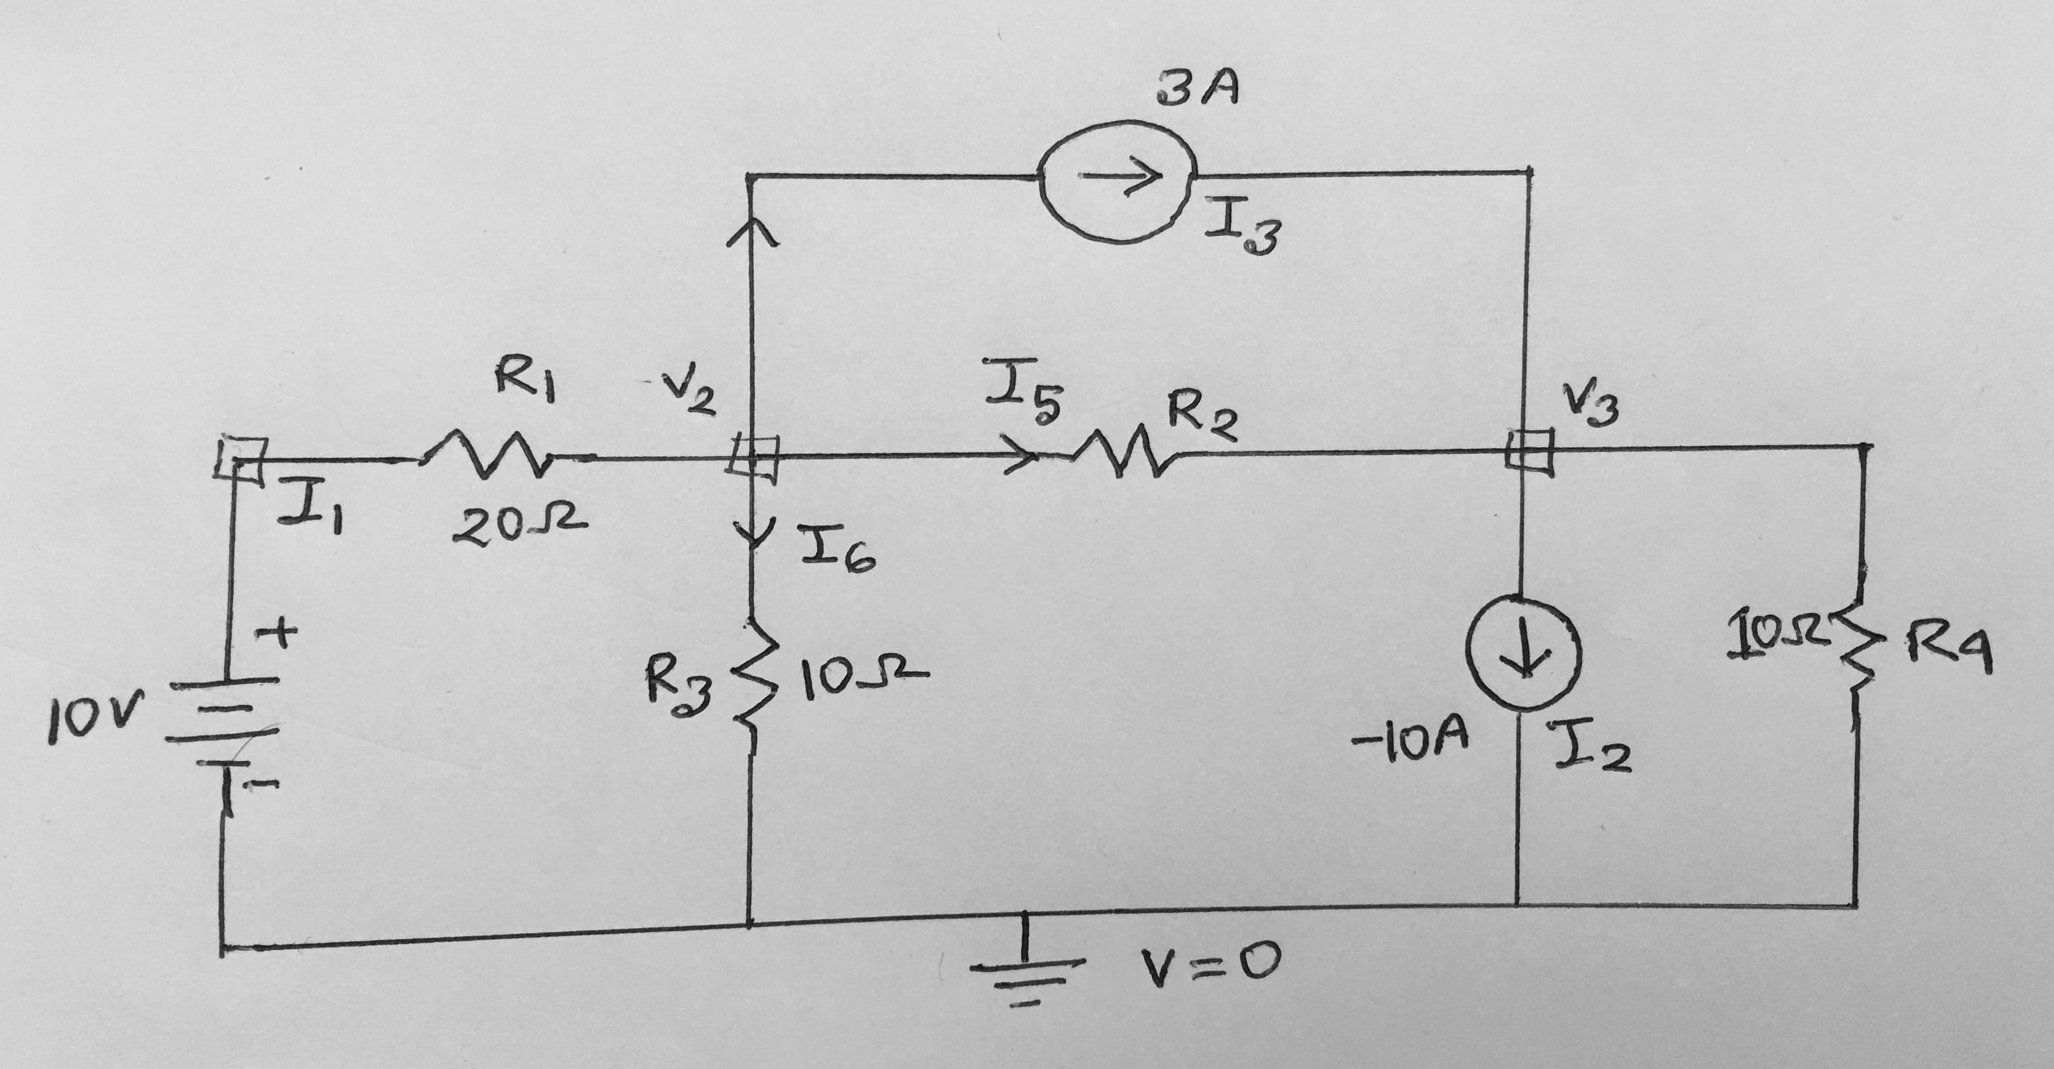

Applying KCL at node 2,

⇒−10−𝑉220+3+𝑉2−𝑉330+𝑉210=0

⇒11𝑉3−2𝑉2=−150

⇒2𝑉3 −11𝑉2=150 …………(1)

Applying KCL at node 3,

⇒−V2−V330−3−10+V310=0

⇒4V3 − V2=390

⇒ V2=4V3 −390…………….(2)

From (1)

2V3 −11 (4V3 −390) =150

⇒−42V3 =−4140

⇒𝑉3 =98.57𝑉

From (2)

V2=4×98.57−390

⇒𝑉2=4.286𝑉

So,

V1= 10V

V2=4.286𝑉 𝑉3

=98.57𝑉

I1=10−𝑉220

=285.71𝑚𝐴

I5=−314.28𝑚𝐴

I4=428.57 𝑚𝐴

I6= 985.7 𝑚𝐴

I2=−10𝐴

I3=3A

**Answers to the questions no: 02**

|  |  |  |  |
| --- | --- | --- | --- |
|  |  | **Theoretical solution** | **PSpice solution** |
| **Voltages** | V1 | 10V | 10V |
|  | V2 | 4.286𝑉 | 4.286𝑉 |
|  | V3 | 98.57𝑉 | 98.57𝑉 |
| **Current** | I1 | 285.71𝑚𝐴 | 285.71𝑚𝐴 |
|  | I2 | −10𝐴 | −10𝐴 |
|  | I3 | 3A | 3A |
|  | I4 | 428.57 𝑚𝐴 | 428.57 𝑚𝐴 |
|  | I5 | −314.28𝑚𝐴 | 314.28𝑚𝐴 |
|  | I6 | 985.7 𝑚𝐴 | 985.7 𝑚𝐴 |

**Result:**

By doing this experiment we are able to simulate our circuits using PSpice and test the results. Previously we had tested our circuits practically, but this is more efficient.

**Conclusion:**

While doing this experiments, the readings were taken very carefully. Though there is some difference between calculated value and PSpice value, at the end of the experiment we finally gained practical knowledge that how to work with PSpice Schematic and independent source.